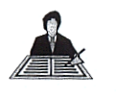Task No 8
What do you understand by a ‘secure frame’ and an ‘insecure frame’.

Task No 9

Please explain:
(a) What are procedural elements?
(b) What is a procedural model?

Task No 10

How do you respond to this chapter about Safe Practice?

Task No 11

To what extent do you find that systems issues arise in your work?

