Task No 6

How would you briefly describe each of the main approaches to counseling conversations?

Task No 7

Try your hand at completing a star for Interviewing.
Below you may wish to note your thoughts about it.

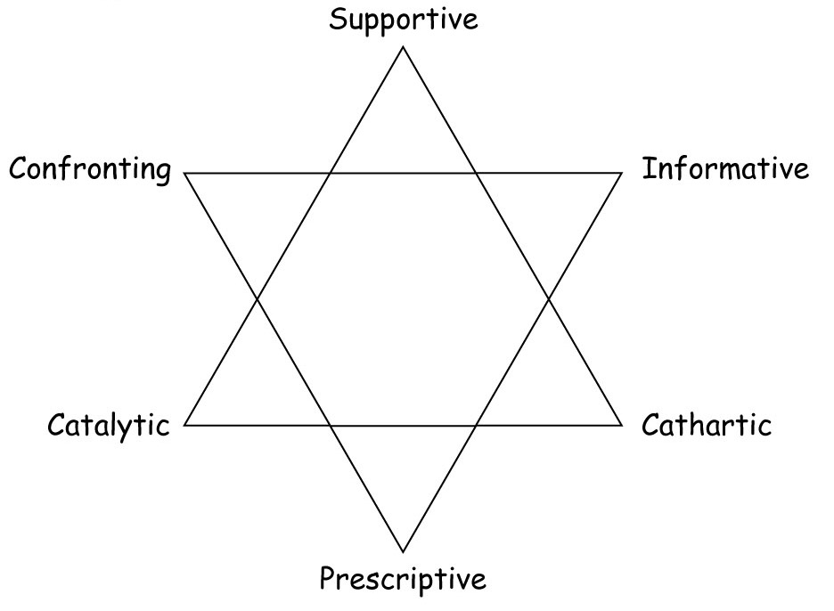
© 2001 John Heron

My Thoughts about Interviewing:
1. Prescriptive

2. Informative

3. Confronting

4 . Cathartic

5. Catalytic

6. Supportive

